Binomial pmf and CDF

Oliver

## pmf

We can use the base plot functions in R to create a plot of the pmf for a binomial random variable $X$ with $n=13$ and $p=0.6$— i.e. $X \overset{̃}{ }B(13, 0.6)$.

n <- 13  
 p <- 0.6  
 x <- -1:14  
 pmf <- dbinom(x, n, p)  
 plot(x, pmf, type="h", xlab="x", ylab="p = P(X=x)", main="X~B(13, 0.6)", ylim=c(0, 0.25), xaxt="n")  
 axis(1,at=seq(0,14,by=2))  
 text(x, pmf+0.005, round(pmf, digits=4), cex=0.6)

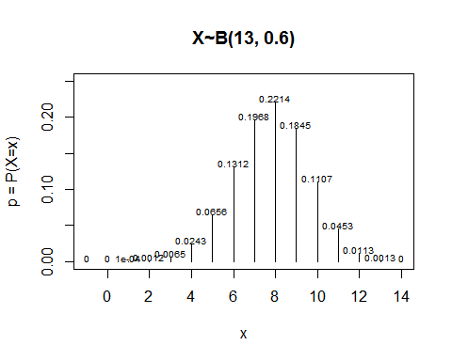

## CDF

The CDF may be plotted analogously.

x <- -1:15  
 cdf <- pbinom(x, n, p)  
 plot(x, cdf, type="s", xlab="x", ylab="P(X<=c)", main="X~B(13, 0.6)", xaxt="n")  
 axis(1, at=seq(0,14,by=2))

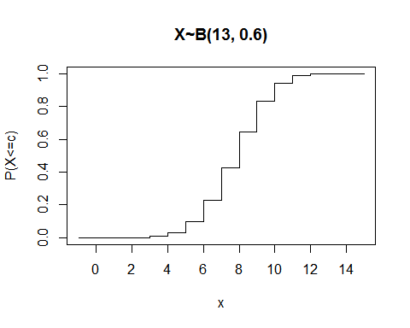

Just for fun we can overlay the two.

pmf <- dbinom(x, n, p)  
 plot(x, pmf, type="h", xlab="x", ylab="p", main="X~B(13, 0.6)", ylim=c(0, 1), xaxt="n", col="red", lty=3)  
 lines(x, cdf, type="s", xlab="x", ylab="P(X<=c)", main="X~B(13, 0.6)", xaxt="n")  
 axis(1,at=seq(0,14,by=2))

